Agilent E4418B Power Meter
A minimum warm- up time of 30 minutes is recommended before accurate measurements can be made.
Prior to making your first measurement, you must zero and calibrate the sensor and meter combination. Refer to Chapter 2 for further information if you are not familiar with zeroing, calibrating or making measurements with a power meter.

POWER REF Output.
The power reference output is a 50 ∧ type- N connector. The output signal of 1 mW at 50 MHz is used for calibrating the sensor and meter combination. Power meters configured with Option 003 have the power reference on the rear panel.

The Display Layout
The following figure details the display layout when two measurement windows are displayed, one analog and one digital.
However, it is possible using the 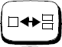 key to display just one measurement window.

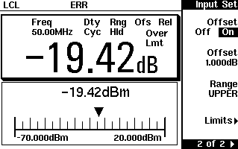
14 13
12 11
10 9

  - Zeroing and Calibrating the Power Meter
This section describes how to zero and calibrate the power meter. You should always zero the power meter prior to calibrating it.

Zeroing the Power Meter
Zeroing adjusts the power meter for a zero power reading with no power applied to the power sensor. During zeroing, which takes approximately 10 seconds, the wait symbol is displayed.
To zero the power meter:
1 Press , Zero. During zeroing, the wait symbol is displayed.

When to Zero?
Zeroing of the power meter is recommended:
  - when a 5 °C change in temperature occurs.
  - when you change the power sensor.
  - every 24 hours.
  - prior to measuring low level signals. For example, 10 dB above the lowest specified power for your power sensor.

Zero/Cal Lockout
The Zero/Cal Lockout facility provides a mean of ensuring that a measurement cannot be taken until the connected sensor has been zeroed and calibrated. If the Zero/Cal Lockout facility is enabled and a sensor is connected which have not been zeroed and calibrated, then the display window for the sensor will display the message “Please Zero + Cal ChA”.
If you zero the sensor before calibrating it, the message changes to “Please Cal ChA”.
If you calibrate the sensor before zeroing it, the message changes to “Please Zero ChA”.

The Zero/Cal Lockout facility can be enabled or disabled through either the System Inputs menu or the Zero Cal menu as follows:
,
,

Press
, Must Cal ,
Off, or
On.

Press
, Must Cal ,
Off, or
On.

Calibrating the Power Meter
Calibration sets the gain of the power meter using a 50 MHz 1 mW calibrator as a traceable power reference. The power meter’s POWER REF output or a suitable external reference is used as the signal source for calibration. An essential part of calibrating is setting the correct reference calibration factor for the power sensor you are using. The Agilent Technologies E4418B Series Power Meter User’s Guide require you to set the reference calibration factor. The Agilent E- Series power sensors and N8480 Series power sensors (excluding Option CFT) set the reference calibration factor automatically. During calibration, the wait symbol is displayed. Offset, relative, and duty cycle settings are ignored during calibration.

During calibration, the power meter automatically switches the power reference calibrator on (if it is not already on), then after calibration, it switches it to the state it was in prior to the calibration.
NOTE

Calibration Procedure using Agilent 8480 Series power sensors and N8480 Series Power Sensors with Option CFT
The following procedure describes how you calibrate the power meter with the Agilent 8480 Series power sensors

There are a variety of methods to connect the power sensors to the power meter depending on the model of power sensor you are using. Refer to Table 2- 1 on page 33 for details on connecting different power sensor models.
- Press .
- Verify the reference calibration factor of your power sensor with that
displayed under Ref CF. The value shown is obtained from the sensor
calibration table if one is selected, otherwise it is the last value set or the default of 100%. If the value is not correct, press Ref CF. The power meter displays the reference calibration factor in a pop- up window. Modify this reference calibration factor (see below) as desired.
  - Use or to modify the digit on which the cursor is currently positioned.
  - Use or to move to other digits.
- To confirm your choice, press %.
- Connect the power sensor to the POWER REF output.
- Press Cal to calibrate the power meter. During calibration, the wait symbol is displayed. (The power meter automatically turns on the POWER REF output.)

Example
To calibrate the power meter with a power sensor whose reference calibration factor is 99.8%.
  - Press 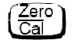.
  - Press Ref CF. Use the , , , and keys to enter 99.8. Press
%.
  - Connect the power sensor to the POWER REF output.
  - Press Cal .

Table 2-1 Power Sensor Connection Requirements

Sensor Model | Connection Requirements
Agilent 8481A | These power sensors connect directly to the reference calibrator.
Agilent 8481D | Prior to the power meter being calibrated an Agilent 11708A 30 dB

Making Measurements using Sensor Calibration Tables
This section applies to all Agilent 8480 Series power sensors
For the Agilent 8480 Series power sensors, there are two methods of providing correction data to the power meter:
- inputting the individual calibration factor for a frequency prior to making the measurement, or
- using sensor calibration tables.
This section describes how to use sensor calibration tables. Sensor calibration tables are used to store the measurement calibration factors, supplied with each power sensor in the power meter. These calibration factors are used to correct measurement results.
Using sensor calibration tables provides you with a quick and convenient method for making power measurements over a range of frequencies using one or more power sensors. The power meter is capable of storing 20 sensor calibration tables of 80 frequency points each.
To use sensor calibration tables you:
- Select the table to work on a channel. Refer to “Selecting a Sensor Calibration Table” on page 45 for further information. If you are required to edit the table, refer to “Editing Sensor Calibration Tables” on page 46 for further information.
- Zero and calibrate the power meter. The reference calibration factor used during the calibration is automatically set by the power meter from the sensor calibration table.
- Specify the frequency of the signal you want to measure. The calibration factor is automatically set by the power meter from the sensor calibration table. Refer to “Making the Measurement” on page 45 for further information.
- Make the measurement.

Selecting a Sensor Calibration Table
You can select a sensor calibration table for use by pressing ,Tabl, Sensor Cal Tables,

Table Off On. The “State” field indicates ifany sensor calibration tables are currently selected. The “Sensor Tbls” screen is displayed as shown in Figure 2- 4.

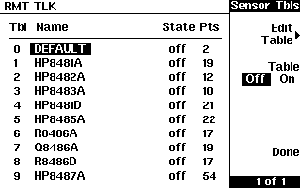

Figure 2-4 “Sensor Tbls” Screen

Making the Measurement
To make the power measurement, you zero and calibrate the power meter, then set it for the frequency of the signal you want to measure. The power meter automatically selects the calibration factor from the sensor calibration table.
- Press .
- Press Zero. During zeroing, which takes approximately 10 seconds, the wait symbol is displayed.
- The setting of the reference calibration factor is obtained from the sensorcalibration table and displayed under the
Ref CF
softkey.onnect the power sensor to the POWER REF output.
- Press Cal to calibrate the power meter. During calibration, the wait symbol is displayed. (The power meter automatically turns on the POWER REF output.)
- Press . The current setting of the frequency is displayed
under the Freq softkey. To change this setting, press Freq. The power meter displays the frequency in a pop- up window. Modify this frequency (see below) as desired.
  - Use or to modify the digit on which the cursor is currently positioned.
  - Use or to move to other digits.
- To confirm your choice, press the appropriate frequency unit.
- Connect the power sensor to the signal to be measured.
- The measurement result is now displayed.

If the measurement frequency does not correspond directly to a frequency in the sensor calibration table, the power meter calculates the calibration factor using linear interpolation.
NOTE

If you enter a frequency outside the frequency range defined in the sensor calibration table, the power meter uses the highest or lowest frequency point in the sensor calibration table to set the calibration factor.

The value of the calibration factor being used by the power meter to make a measurement is displayed under the Cal Fac softkey.

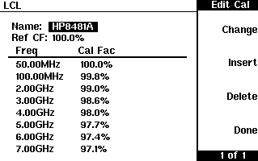

Figure 2-5 “Edit Cal Screen”

The power meter is shipped with a set of predefined sensor calibration tables. The data in these tables is based on statistical averages for a range of Agilent Technologies power sensors.
These power sensors are:
  - DEFAULT1
  - HP 8481A
  - HP 8482A2
  - HP 8483A
  - HP 8481D
  - HP 8485A
  - HP R8486A
  - HP Q8486A
  - HP R8486D
  - HP 8487A
There are also ten sensor calibration tables named CUSTOM_0 through CUSTOM_9 which do not contain any data when the power meter is shipped from the factory.

- DEFAULT is a sensor calibration table in which the reference calibration factor and calibration factors are 100%. This sensor calibration table can be used during the performance testing of the power meter.
- The Agilent 8482B and Agilent 8482H power sensors use the same data as the Agilent 8482A.

Setting the Units of Measurement
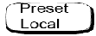
The “dBm/W” menu is used to select the measurement units on the currently selected window. These can either be logarithmic (dBm or dB) or linear (Watt or %) units. sets the measurement units to dBm (logarithmic units). Table 2- 5 shows which units are applicable to the individual measurement modes.
Press , then select the unit of measurement from dBm, W, dB,
or %. Softkeys which cannot be selected in your particular mode of
operation appear with their text grayed out.

Setting the Resolution
The resolution of each of the power meter’s windows can be set to four different levels (1, 2, 3, or 4).
These four levels represent:
- 1, 0.1, 0.01, 0.001 dB respectively if the measurement suffix is dBm or dB.
- 1, 2, 3, or 4 significant digits respectively if the measurement suffix is W or %.
The default value is 0.01 dB (3 digits).
To set the resolution on the currently selected window:
- Press . The current setting of the resolution is highlighted on the Resolution 1 2 3 softkey.
- To change this setting, press Resolution 1 2 3 until the required
resolution setting is highlighted.

Setting Averaging
The power meter uses a digital filter to average power readings. The number of readings averaged can range from 1 to 1024. This filter is used to reduce noise, obtain the desired resolution and to reduce the jitter in the measurement results. Increasing the value of the filter length reduces measurement noise. However, the time to take the measurement is increased. You can select the filter length or you can set the power meter to auto filter mode. The default is “AUTO”.
When the auto filter mode is enabled, the power meter automatically sets the number of readings averaged together to satisfy the filtering requirements for most power measurements. The number of readings averaged together depends on the resolution and the power level currently being measured. Figure 2- 9 lists the number of readings averaged for each range and resolution when the power meter is in auto filter mode and is set to normal speed mode (refer to the Agilent EPM- 4418B/4419B Programming Guide for details of the readings averaged in the other speed modes).
Resolution is a window function and not a channel function. In the case, where a channel is set up in both the upper and lower window and the resolution settings are different, the highest resolution setting is taken to calculate the averaging number. For example, if the upper window has a resolution setting of two and is measuring channel A and the lower window has a resolution of four and is also measuring channel A. In this instance, channel A averaging is calculated with a resolution of four.

To set averaging:

- Press ,
Input Settings, . Press the
Filter
softkey to

access the filter menu.
- The current setting of averaging is displayed under the

Length

softkey.

To change this setting, press Length. A pop- up window appears. Use
the , , , or keys to set your filter length.
- To confirm your choice, press Enter.
The filter can be disabled and re- enabled simply by pressing Filter Off On.

Power Meter Specifications

Frequency Range _ 100 kHz to 110 GHz, power sensor dependent

Power Range _–70 dBm to +44 dBm (100 pW to 25 W), power sensor dependent

Power Sensors _Compatible with all Agilent 8480 Series power sensors

Single Sensor_Dynamic Range _ 50 dB maximum (Agilent 8480 Series power sensors)

Display Units_Absolute: _ Watts or dBm

Display Resolution _ Selectable resolution, Default Resolution 0.01 dB in logarithmic mode 3 digits in linear mode

Accuracy

Instrumentation
Absolute: ±0.02 dB (Logarithmic) or ±0.5% (Linear). (Refer to the power sensor linearity specification in your power sensor manual to assess overall system accuracy.)
Relative: ±0.04 dB (Logarithmic) or ±1.0% (Linear). (Refer to the power sensor linearity specification in your power sensor manual to assess overall system accuracy.)
Zero Set (digital settability of zero): Power sensor dependent (refer to Table 5- 1). For Agilent E- Series, 8480 Series and N8480 Series power sensors, this specification applies when zeroing is performed with the sensor input disconnected from the POWER REF.

Table 5-1 Zero Set Specifications

Power Sensor | Zero Set
Agilent 8481A1 | ±50 nW
Agilent 8481D1 | ±20 pW

mW Power Reference1

Power Output
1.00 mW (0.0 dBm). Factory set to ±0.4% traceable to National Physical Laboratory (NPL), UK.

Accuracy (for two years)
±0.9% (0 to 55 ºC)
±0.6% (25 ± 10 ºC)
±0.5% (23 ± 3 ºC)

SWR2
1.06 maximum (1.08 maximum for Option 003)

Frequency
50 MHz nominal

Connector
Type- N (f), 50 ∧

- National metrology institutes of member states of the Metre Convention, such as the National Institute of Standards and Technology in the USA, are signatories to the Comité International des Poids et Mesures Mutual Recognition Arrangement. Further information is available from the Bureau International des Poids et Mesures, at http://www.bipm.fr/
- This SWR specification is only warranted for the E4418B and the E4419B Power Meters with serial prefix GB4331xxxx/MYxxxxxxxx and above. Prior to this prefix the values shown are supplemental characteristics.

Measurement Noise
Power sensor dependent (refer to Table 5- 2 and Table 5- 3).
Averaging effects on measurement noise. Averaging over 1 to 1024 readings is available for reducing noise. Table 5- 3 provides the measurement noise for a particular power sensor with the number of averages set to 16 for normal mode and 32 for x2 mode. Use the “Noise Multiplier” for the appropriate mode (normal or x2) and number of averages to determine the total measurement noise value.
For example, for an Agilent 8481D power sensor in normal mode with the number of averages set to 4, the measurement noise is equal to:
(<45 pW x 2.75) = <124 pW

Table 5-2 Noise Multiplier

Number of Averages | 1 | 2 | 4 | 8 | 16 | 32 | 64 | 128 | 256 | 512 | 1024
Noise Multiplier (Normal Mode) | 5.5 | 3.89 | 2.75 | 1.94 | 1.0 | 0.85 | 0.61 | 0.49 | 0.34 | 0.24 | 0.17
Noise Multiplier (x2 mode) | 6.5 | 4.6 | 3.25 | 2.3 | 1.63 | 1.0 | 0.72 | 0.57 | 0.41 | 0.29 | 0.2

Table 5-3 Power Sensor Specifications±

Power Sensor | Zero Drift1 | Measurement Noise2
Agilent 8481A3 | <±10 nW | <110 nW
Agilent 8481B3 | <±10 mW | <110 mW
Agilent 8481D3 | <±4 pW | <45 pW

Recorder Output
The rear panel Recorder Output connector produces a DC voltage that corresponds to the power level in Watts of the channel. This DC voltage ranges from 0 to +1 Vdc. The output impedance is typically 1 k ohm.
For example, the Recorder Output can be used to;
- record swept measurements on an X- Y recorder
- level an output from a source using external leveling or
- monitor the output power on a strip chart recorder. A setup for recording swept measurements is shown in Figure 2- 20.
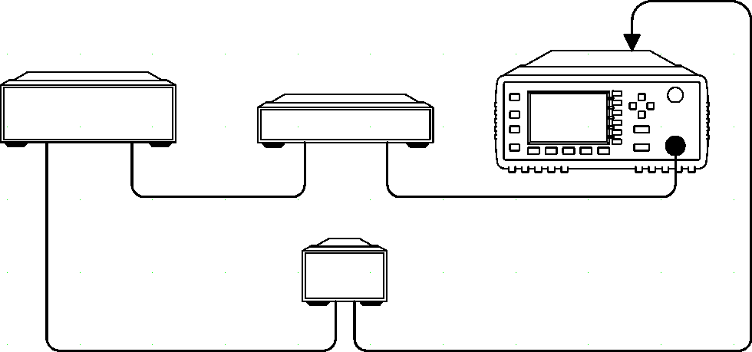
See Figure 2- 22 for details on which power meter functions are implemented in the recorder output.

Swept Source

Device Under Test
RECORDER OUTPUT

SWEEP OUT

RF OUT

IN

  - Recorder

OUT

Power Meter

CHANNEL A INPUT

X-AXIS (FREQUENCY) Y-AXIS (POWER)

Figure 2-20 Test Setup for Recording Swept Measurements

To access the “Recorder” menu, press , , Recorder Output.
This menu allows you to switch the Recorder Output signal either on or

off. The
Max Power
and
Min Power
softkeys allow you to enter the input

power level that you want to represent the 1 Vdc maximum and 0 Vdc minimum output voltage of the Recorder Output.

Leveling a Source Output
The Recorder output can be used to level an output from a source using external leveling. The following procedure explains how to do this:
    - Select the Recorder Output by pressing , , Recorder Output.
    - The highest power you are going to measure is used to determine the value which you should set for the Recorder Output maximum setting. For example, if you are measuring a power less than 1 mW and greater than 100 µW, then set the recorder maximum value to 1 mW.

50 dBm (100 W)
40 dBm (10 W)
30 dBm (1 W)
20 dBm (100 mW)
10 dBm (10 mW)
0 dBm (1 mW)
–10 dBm (100 µW)
–20 dBm (10 µW)
–30 dBm (1 µW)
–40 dBm (100 nW)
–50 dBm (10 nW)
–60 dBm (1 nW)

    - To set the maximum value, press value.
Max Power
and enter the appropriate

    - Press Min Power and enter 0 W.

    - Press
Output Off On
to “On”.

Use set up saved as state 2

